Excel with ChatGPT

- 🔴 System Prompt - Today I will be working on Microsoft Excel (Office 365). I want ChatGPT to act as an Excel expert and assist me with formulas, functions, data analysis, dashboards, charts, PivotTables, Power Query, VBA (if needed), and best practices. Please provide step-by-step guidance with clear explanations and practical examples suitable for real-world use.

✴️ Exercise - 1
- 🔴 Prompt - Create sales data in a tabular format for 20 real life like FMCG items as row heads and 12 months names (e.g. Jan, Feb, to Dec) as column heads and sales data between 100 to 600 in the body. Don't generate any Python code, generate the table directly and accordingly.
- ✅ Copy the generated data and paste them to one blank excel worksheet at cell A1.
- 🔴 Prompt - Write the formulas to calculate Total, Maximum, Minimum, Average, Second Highest, Second Lowest for the data items from cell B2 to M2.
- ✅ Copy all the generated formulas and paste them in the respective columns from N2 to S2, and drag them for rest of the column values.
- ✅ Give the column heads appropriately e.g. Total, Maximum, Minimum, Average, Second Highest, Second Lowest.
- ✅ At cell T1 give a column head 'Status'
- 🔴 Prompt - Write one excel formula such that if N2 cell values is below 4000 then "Low Sale", if it is between 4000 to 5000 then "Medium Sale" otherwise "High Sale".
- ✅ Now copy the formula and paste it to the cell T2 and drag it for rest of the column values. These limit values may have to be readjusted depending upon your generate data values.
- 🔴 Prompt - Please write the steps to convert dataset at A1 to T21 to a table.
- ✅ Follow the steps given to do the needful actions to convert the dataset to a table.
☑️ Output:
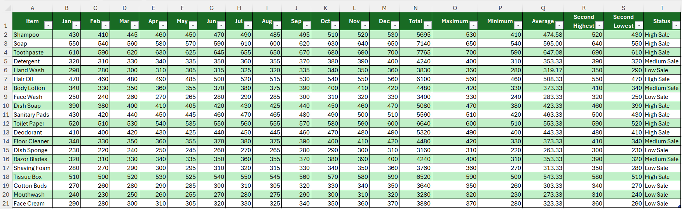

✴️ Exercise - 2
- 🔴 Prompt - Generate a table with column head 'Data' where there will be 20 data items containing 'Name', 'Age', 'Email' and 'Reg. No.' separated by commas.
- ✅ Copy the generated data and paste them to one blank excel worksheet at cell A1.
- 🔴 Prompt - Write a formula in Excel which will split 'Name', 'Age', 'Email' and 'Reg. No.' separated by commas at cell A2.
- ✅ Copy the generated formula and paste it at cell B2 and drag them for rest of the column values.
- ✅ Give the column heads appropriately e.g. 'Name', 'Age', 'Email' and 'Reg. No.'.
- 🔴 Prompt - In columns B to E from rows 2 to 21, we have Name, Age, Email, Reg. No. for employees. Mention steps to create a drop-down list on Name at cell K2.
- ✅ Follow the mentioned steps and create the drop-down list accordingly.
- 🔴 Prompt - Please mention formulas to get Age, Email and Reg. No. of that employee whose name is at cell K2 based on the above-mentioned table.
- ✅ Follow the given instructions. Copy the formulas and paste them at cells K3, K4 and K5 respectively.
☑️ Output:
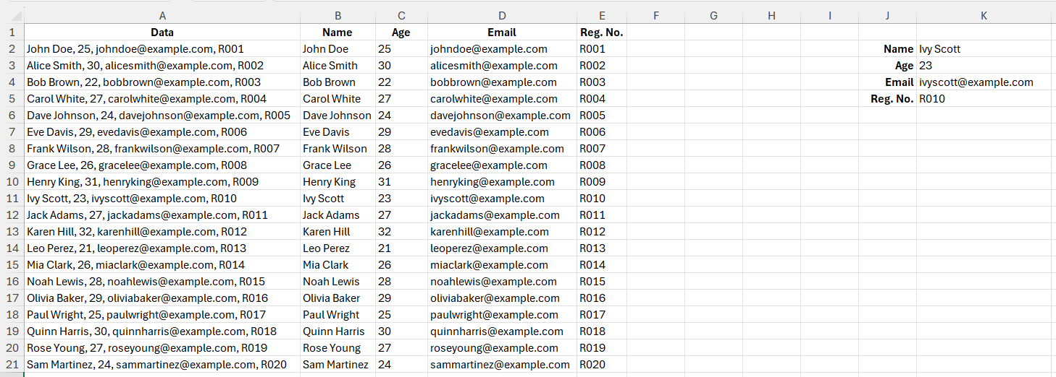

✴️ Exercise - 3
- 🔴 Prompt - Generate a table with columns 'Employee Name' and 'Login Time' for 20 employees. All the 'Login Time' should be between 8.45am to 9.15am.
- ✅ Copy the generated data and paste them to one blank excel worksheet at cell A1.
- 🔴 Prompt - The time value is in cell B2. Write a formula if the time is less than or equal to 9 AM then "On Time" otherwise "Late Arrival"
- ✅ Copy the generated formula and paste it at cell C2 and drag them for rest of the column values.
- ✅ Give the column head as 'Arrival'.
- 🔴 Prompt - Please mention steps to highlight cell from C2:C21 if it is 'Late Arrival'.
- ✅ Follow the steps and do the needful conditional formatting.
☑️ Output:
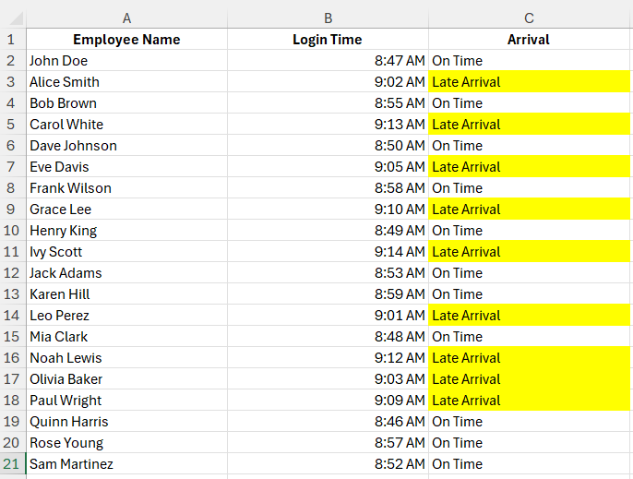

✴️ Exercise - 4
- 🔴 Prompt - Create an Excel Macro to make an 'EMI Calculator' along with full payment schedule and calculations.
- ✅ Follow all the steps as mentioned in the instruction list and do the needful.
☑️ Output:
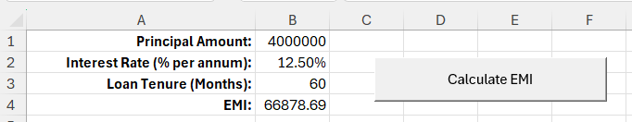

✴️ Exercise - 5
- 🔴 Prompt - Create a list of 20 records with EmpName and EmpEmail.
- ✅ Copy paste the data set in Sheet5 at cell A1.
- 🔴 Prompt - Create another list of 25 records with EmpName and EmpEmail keeping some records same as were in the previous list generated.
- ✅ Copy paste the data set in Sheet6 at cell A1.
- 🔴 Prompt - I am having data in Sheet5 A1 to B21 and in Sheet6 A1:B26 with headings 'EmpName' and 'EmpEmail'. Select only duplicate data in these two sheets and copy them in Sheet7 in A and B columns with proper headings.
- ✅ Follow all the steps as mentioned in the instruction list and do the needful.
☑️ Output:
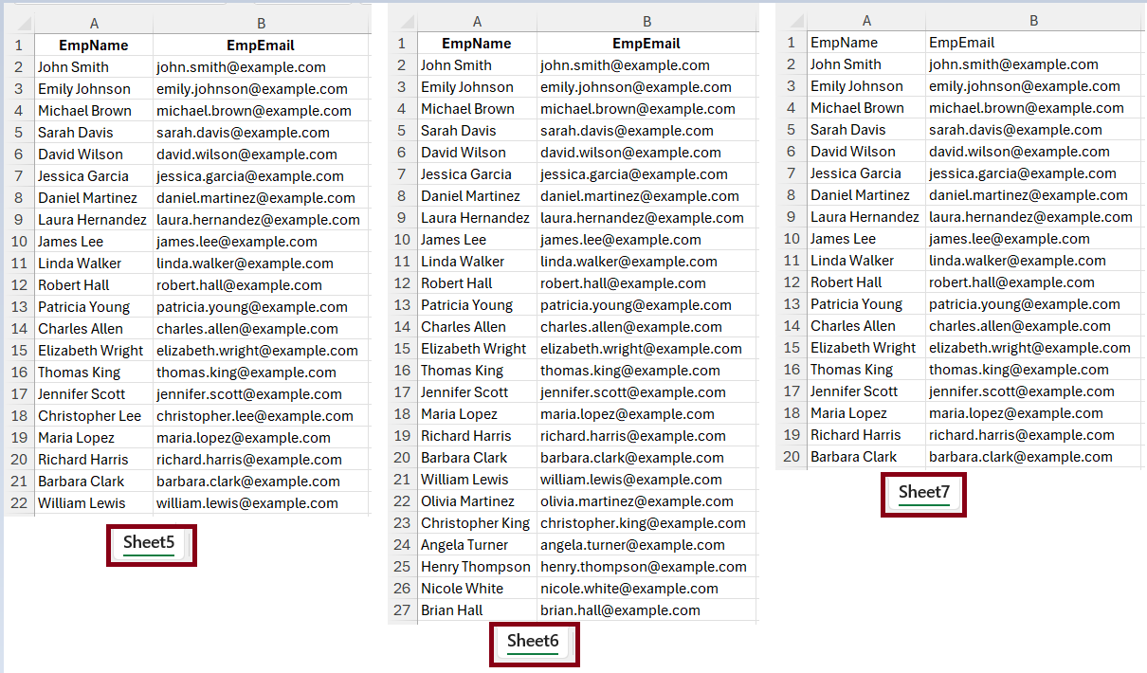

✴️ Exercise - 6
- 🔴 Prompt - Create sales data in a tabular format for 10 real life like building construction items as row heads and 12 months names (e.g. Jan, Feb, to Dec) as column heads and sales data in the body. Don't generate any Python code, generate the table directly and accordingly.
- ✅ Copy the generated data and paste them to one blank excel worksheet at cell A1.
- 🔴 Prompt - Item Name is given in cell Q2 and Month is given in cell Q3. Now generate a formula to find the sales amount in cell Q4 from the pre-generated table whose top-left header cell is at A1.
- ✅ Copy the generated formula and paste it to the cell Q4.
- 🔴 Prompt - Now also generate the steps to highlight the cell whose value is getting selected for that specific given Item Name and the Month based on the previous table whose top left header cell is at A1.
- ✅ Follow all the steps as mentioned in the instruction list and do the needful. We may require a correction of the ChatGPT given formula. The correct formula will be - =AND($A2=$Q$2, B$1=$Q$3) against the selection B2:M11.
☑️ Output:
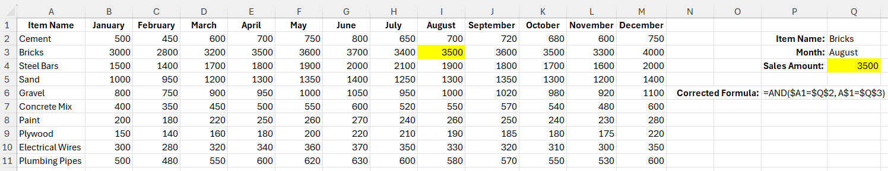

✴️ Exercise - 7
- 🔴 Prompt -
Write a Basic VBA Code to create 5 new sheets from Sheet11 to Sheet15 every time we run the macro in a new workbook and also format the sheets with the below requirements:
a. Background color is cyan for all the cells of the current sheet.
b. Font color is deep blue.
c. Font style is bold and italics.
d. Width of all the columns 20.
e. Height of the first row should be 20.
f. Cell A1 of each sheet will contain the worksheet name.
- ✅ After creation of the macro, run the macro as instructions are given.
- ✅ Go to Home -> Cell (Group) -> Format, to verify the row and column widths.
☑️ Output:
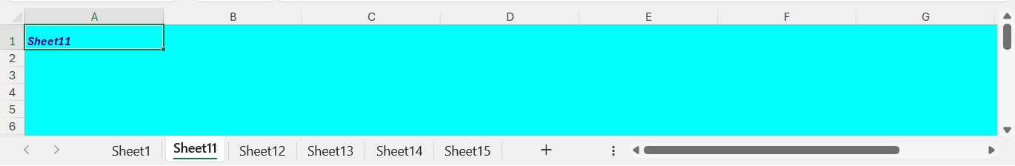

✴️ Exercise - 8
- 🔴 Prompt - Create a dataset for 20 employees with First_Name, Last_Name, Gender, CTC between 5 Lac USD to 1 Crore USD. The First_Name and Last_Name columns will have values with mix of upper-case and lower-case letters arbitrarily.
- ✅ Copy the generated data and paste them to one blank excel worksheet at cell A1.
- 🔴 Prompt -
I am having a dataset with column heads First_Name, Last_Name, Gender, CTC (USD) in row 1 starting from cell A1.
Now we require formulas to create new columns as mentioned below -
1. Full_Name: Combine First and Last Names and make them proper. And also prepend salutation 'Mr.' if 'Gender' is 'Male', otherwise 'Ms.'.
2. CTC in Lakhs: Convert CTC from USD to Lakhs (1 Lakh = 100,000 USD)
3. Gender_Code: Assign a code based on Gender (e.g., Male = 1, Female = 2)
4. CTC Category: Categorize CTC as Low, Medium, or High, if < 6000000, if >= 6000000 and < 8000000, otherwise respectively.
- ✅ Create column heads Full_Name, CTC in Lakhs, Gender_Code and CTC Category. Put required formulas under them as suggested.
- ✅ Now drag those formulas for the rest of the cells in those columns.
☑️ Output:
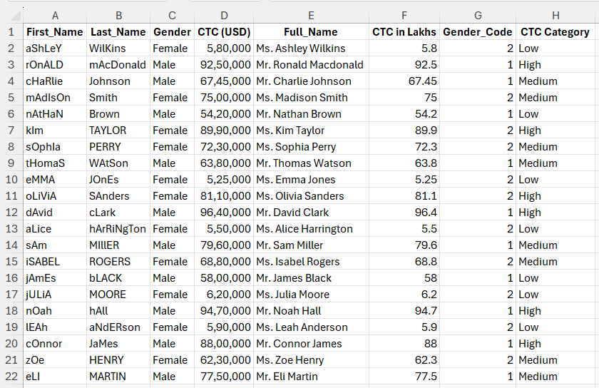

✴️ Exercise - 9
- 🔴 Prompt - Create a table containing distinct EmpID, EmpName and EmpDept, where EmpDept has four distinct department names only.
- ✅ Copy the generated data and paste them to one blank excel worksheet at cell A1.
- 🔴 Prompt -
There is a dataset from A1 to C21 including header row containing EmpID, EmpName, EmpDept. Now find the following formulas to do the needful calculations -
1. Count of distinct department names.
2. Count of all employees.
3. List of distinct department names to be put from the column cell E6 onward.
4. Employee count of each distinct department.
- ✅ Now put proper headings as required and copy the respective formulas as suggested by ChatGPT to the respective worksheet cells.
☑️ Output:
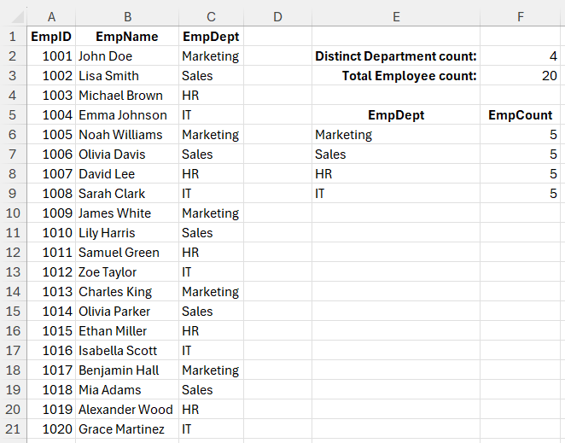

✴️ Exercise - 10
- 🔴 Prompt - Please create 2024 sales dataset with 200 rows against the column heads Date, Product, Employee, Units Sold, Price per Unit (INR), Region, Total Amount (INR). We are having 10 distinct products and 5 Employees for the sales. Give these products and employees realistic names. Don't generate any Python code, generate one download link to download the MS-Excel workbook directly and accordingly.
- 🔴 Prompt - Clean and format our whole dataset.
- 🔴 Prompt - I want to download the dataset.
- 🔴 Prompt - Give me a bar chart for "Total Sales by Product".
- 🔴 Prompt - Can you summarize the key insights?
- 🔴 Prompt - Show me a trend analysis of sales.
- 🔴 Prompt - How about comparing "Profitability by Region"?
- 🔴 Prompt - Can we analyze "Sales by Product"?
- 🔴 Prompt - Generate a scatter plot "Units Sold" vs. "Price per Unit (INR)".
- 🔴 Prompt - Generate a pie chart for "Sales Distribution by Region".
- 🔴 Prompt - Draw suitable line diagrams with markers based on the given dataset.
- 🔴 Prompt - Suggest some more data visualizations based on the given dataset.
- 🔴 Prompt - Can you draw all these suggested graphs and charts?
☑️ Output:
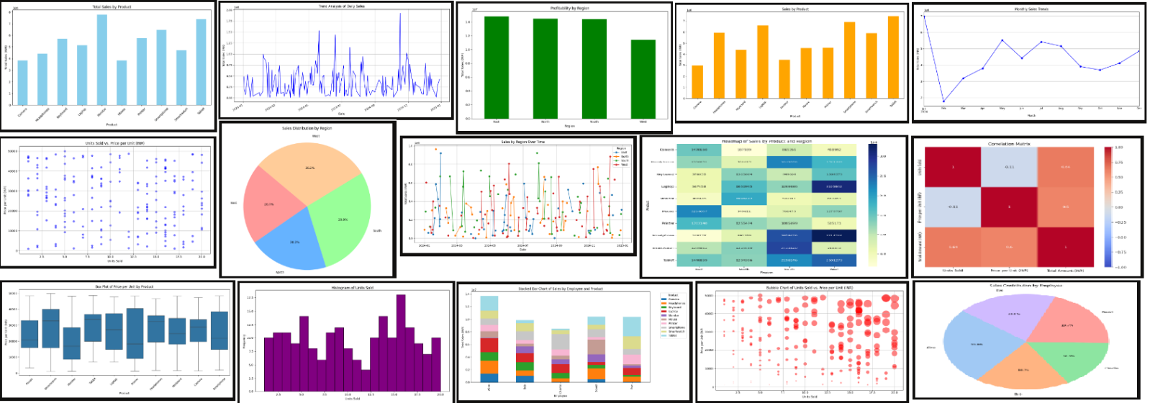

✴️ Exercise - 11
- ✅ Go to Home tab, click on Add-ins and add "ChatGPT for Excel".
- ✅ Watch YouTube official video at https://www.youtube.com/watch?v=4raUaR-FK-M for more details.
- ✅ Check the complete official documentation at https://appsource.microsoft.com/en-us/product/office/WA200005271?src=office&corrid=4e5d4162-8729-dbd3-9d38-ddaa55bf5012&omexanonuid=&referralurl=&ClientSessionId=b98ee656-7fc1-4fa9-99c6-c9b0a1acc093.
- ✅ Here are just a few examples of how our add-in can help you sparkle:
- AI.ASK: let AI answer questions and write engaging content
- AI.TABLE: create AI-powered tables in seconds
- AI.TRANSLATE: translate your content into dozens of languages
- AI.FORMAT: quickly format your data with AI for consistency
- AI.EXTRACT: extract valuable data insights
- AI.FILL: clean your data and fill in missing ranges
- AI.LIST: generate list outputs in separate rows
- AI.CHOICE: chooses the most closely matching value from a given list of choices

✴️ Exercise - 12
✅1️⃣ AI.ASK
- 🔴 Prompt - Explain the purpose of AI.ASK in details with multiple suitable examples.
☑️ Output:
AI.ASK
The AI.ASK function in Excel is designed to leverage the power of AI to answer questions, generate content, and provide insights directly within your spreadsheet. This function is highly versatile and can be used for a variety of tasks, making it a valuable tool for enhancing productivity and efficiency.
Purpose:
- Content Generation: Create high-quality content such as summaries, reports, emails, and descriptions without leaving Excel.
- Information Retrieval: Quickly get answers to specific questions, helping you make informed decisions based on the data in your spreadsheet.
- Data Analysis: Provide insights and explanations for complex data, making it easier to understand and interpret your data.
Examples:
- Generating a Summary:
  - Scenario: You have a lengthy sales report and need a concise summary.
  - Usage: =AI.ASK("Write a summary of the latest sales report")
  - Output: "The latest sales report shows a significant increase in sales for the North region, with a total revenue of ₹13,375,763. The top-performing product was the Mouse, contributing ₹6,759,867 to the total sales."
- Creating an Email Draft:
  - Scenario: You need to draft an email to inform your team about the quarterly sales performance.
  - Usage: =AI.ASK("Draft an email to the team about the quarterly sales performance")
  - Output: "Dear Team, I am pleased to inform you that our quarterly sales performance has exceeded expectations. The North region led the way with a total revenue of ₹13,375,763. Keep up the great work! Best regards, [Your Name]"
- Explaining Data Trends:
  - Scenario: You notice a spike in sales during a particular month and want to understand why.
  - Usage: =AI.ASK("Explain the spike in sales during March 2024")
  - Output: "The spike in sales during March 2024 can be attributed to the successful launch of the new Smartwatch model, which saw a high demand and contributed significantly to the overall sales."
- Generating Product Descriptions:
  - Scenario: You need to create descriptions for new products in your inventory.
  - Usage: =AI.ASK("Generate a description for a new high-end laptop")
  - Output: "Introducing our latest high-end laptop, featuring a sleek design, powerful performance with the latest Intel i9 processor, 16GB RAM, and a stunning 4K display. Perfect for professionals and gamers alike."
- Providing Insights:
  - Scenario: You want to understand the performance of different sales regions.
  - Usage: =AI.ASK("Provide insights on the performance of different sales regions")
  - Output: "The North region has shown the highest sales performance with a total revenue of ₹13,375,763, followed by the South region with ₹13,701,058. The East and West regions also performed well, contributing ₹11,062,791 and ₹12,216,647 respectively."
By using the AI.ASK function, you can streamline your workflow, save time on manual tasks, and gain valuable insights directly within Excel.

✅2️⃣ AI.CHOICE
- 🔴 Prompt - Explain the purpose of AI.CHOICE in details with multiple suitable examples.
☑️ Output:
AI.CHOICE
The AI.CHOICE function in Excel is designed to help categorize data by choosing the most closely matching value from a given list of choices. This function is particularly useful for data classification and decision-making tasks, making it easier to manage and analyze large datasets.
Purpose:
- Data Classification: Automatically categorize items based on predefined choices, ensuring consistency and accuracy in data classification.
- Decision Support: Assist in making decisions by selecting the most appropriate option from a list of choices.
- Efficiency: Save time by automating the process of categorizing and classifying data.
Examples:
- Categorizing Products:
  - Scenario: You have a list of products and need to categorize them into different product categories.
  - Usage: =AI.CHOICE("Which product category does 'Smartwatch' belong to?", {"Electronics", "Accessories", "Wearables"})
  - Output: The function will select the most appropriate category for the product "Smartwatch", such as "Wearables".
- Classifying Customer Feedback:
  - Scenario: You have a list of customer feedback comments and need to classify them into categories like "Positive", "Negative", and "Neutral".
  - Usage: =AI.CHOICE("Classify this feedback: 'The product quality is excellent and delivery was fast.'", {"Positive", "Negative", "Neutral"})
  - Output: The function will classify the feedback as "Positive".
- Assigning Priority Levels:
  - Scenario: You need to assign priority levels to a list of tasks based on their descriptions.
  - Usage: =AI.CHOICE("Assign a priority level to this task: 'Fix critical bug in the software.'", {"High", "Medium", "Low"})
  - Output: The function will assign a "High" priority level to the task.
- Determining Regions:
  - Scenario: You have a list of cities and need to determine which region they belong to.
  - Usage: =AI.CHOICE("Which region does 'Mumbai' belong to?", {"North", "South", "East", "West"})
  - Output: The function will determine that "Mumbai" belongs to the "West" region.
- Classifying Emails:
  - Scenario: You need to classify a list of emails into categories like "Work", "Personal", and "Spam".
  - Usage: =AI.CHOICE("Classify this email: 'Meeting agenda for next week.'", {"Work", "Personal", "Spam"})
  - Output: The function will classify the email as "Work".
- Selecting Appropriate Actions:
  - Scenario: You need to decide on the appropriate action to take based on a given situation.
  - Usage: =AI.CHOICE("What action should be taken for this issue: 'Server downtime reported.'", {"Restart server", "Notify IT team", "Ignore"})
  - Output: The function will select "Notify IT team" as the appropriate action.
By using the AI.CHOICE function, you can quickly and easily categorize and classify data, making it easier to manage and analyze large datasets. This enhances the accuracy and efficiency of data management tasks, ensuring consistent and reliable results.

✅3️⃣ AI.EXTRACT
- 🔴 Prompt - Explain the purpose of AI.EXTRACT in details with multiple suitable examples.
☑️ Output:
AI.EXTRACT
The AI.EXTRACT function in Excel is designed to extract specified data from a given text. This function is highly useful for pulling out key data points from large text blocks, such as extracting emails, phone numbers, or other specific information, making data management more efficient.
Purpose:
- Data Extraction: Automatically extract specific information from text, such as emails, phone numbers, addresses, or any other data points.
- Data Cleaning: Simplify the process of cleaning and organizing data by extracting relevant information.
- Efficiency: Save time by automating the extraction of key data points from large text blocks.
Examples:
- Extracting Email Addresses:
  - Scenario: You have a list of customer feedback and need to extract email addresses.
  - Usage: =AI.EXTRACT("Extract email addresses from this text")
  - Output: The function will pull out all email addresses from the provided text, making it easy to compile a list of customer emails.
- Extracting Phone Numbers:
  - Scenario: You have a document with contact information and need to extract phone numbers.
  - Usage: =AI.EXTRACT("Extract phone numbers from this text")
  - Output: The function will identify and extract all phone numbers from the text, organizing them into a list.
- Extracting Addresses:
  - Scenario: You have a list of customer orders with embedded addresses and need to extract the addresses.
  - Usage: =AI.EXTRACT("Extract addresses from this text")
  - Output: The function will extract all addresses from the text, making it easy to compile a list of customer addresses.
- Extracting Dates:
  - Scenario: You have a document with various events and need to extract the dates.
  - Usage: =AI.EXTRACT("Extract dates from this text")
  - Output: The function will identify and extract all dates from the text, organizing them into a list.
- Extracting Names:
  - Scenario: You have a list of meeting minutes and need to extract the names of attendees.
  - Usage: =AI.EXTRACT("Extract names from this text")
  - Output: The function will pull out all names from the text, making it easy to compile a list of attendees.
- Extracting Order Numbers:
  - Scenario: You have a document with order details and need to extract order numbers.
  - Usage: =AI.EXTRACT("Extract order numbers from this text")
  - Output: The function will identify and extract all order numbers from the text, organizing them into a list.
By using the AI.EXTRACT function, you can quickly and easily pull out specific data points from large text blocks, simplifying the process of data cleaning and organization. This enhances the efficiency and accuracy of data management tasks, making it easier to work with large datasets.

✅4️⃣ AI.FILL
- 🔴 Prompt - Explain the purpose of AI.FILL in details with multiple suitable examples.
☑️ Output:
AI.FILL
The AI.FILL function in Excel is designed to fill in missing data based on examples provided. This function is highly useful for completing incomplete data ranges, generating consistent data entries, and automating repetitive data entry tasks.
Purpose:
- Data Completion: Automatically fill in missing data points based on patterns and examples provided.
- Consistency: Ensure consistent data entries across large datasets.
- Efficiency: Save time by automating repetitive data entry tasks.
Examples:
- Filling in Missing Product Descriptions:
  - Scenario: You have a list of products with some missing descriptions.
  - Usage: =AI.FILL(A2:A10, "Generate product descriptions")
  - Output: The function will generate descriptions for the products based on the examples provided, ensuring all products have consistent and complete descriptions.
- Completing Customer Information:
  - Scenario: You have a customer database with some missing email addresses.
  - Usage: =AI.FILL(B2:B10, "Fill in missing email addresses")
  - Output: The function will fill in the missing email addresses based on the patterns and examples in the existing data.
- Generating Consistent Data Entries:
  - Scenario: You need to ensure that all entries in a column follow a specific format.
  - Usage: =AI.FILL(C2:C10, "Ensure consistent format for phone numbers")
  - Output: The function will reformat all phone numbers in the specified range to follow a consistent format, such as (123) 456-7890.
- Populating Sales Data:
  - Scenario: You have a sales dataset with some missing values for units sold.
  - Usage: =AI.FILL(D2:D10, "Fill in missing units sold")
  - Output: The function will estimate and fill in the missing values for units sold based on the patterns in the existing data.
- Completing Address Information:
  - Scenario: You have a list of customer addresses with some missing city names.
  - Usage: =AI.FILL(E2:E10, "Fill in missing city names")
  - Output: The function will fill in the missing city names based on the patterns and examples in the existing data.
- Generating Consistent Product Codes:
  - Scenario: You need to generate consistent product codes for a list of products.
  - Usage: =AI.FILL(F2:F10, "Generate consistent product codes")
  - Output: The function will generate product codes for the products based on the examples provided, ensuring all products have consistent and unique codes.
By using the AI.FILL function, you can quickly and easily complete incomplete data ranges, ensure consistency in your data entries, and save time on repetitive data entry tasks. This enhances the accuracy and reliability of your datasets, making data management more efficient and effective.

✅5️⃣ AI.FORMAT
- 🔴 Prompt - Explain the purpose of AI.FORMAT in details with multiple suitable examples.
☑️ Output:
AI.FORMAT
The AI.FORMAT function in Excel is designed to convert text into a specified format directly within your spreadsheet. This function is highly useful for reformatting text into different styles, such as formal letters, bullet points, or other structured formats, making it easier to present and organize information.
Purpose:
- Text Reformatting: Convert text into various formats to suit different purposes, such as formal letters, reports, or presentations.
- Content Structuring: Organize text into structured formats like bullet points, numbered lists, or paragraphs.
- Consistency: Ensure consistency in the presentation of text across different documents and reports.
Examples:
- Formatting a Formal Letter:
  - Scenario: You need to format a block of text as a formal letter.
  - Usage: =AI.FORMAT("Format this text as a formal letter")
  - Output:
  - [Your Name]
  - [Your Address]
  - [City, State, ZIP Code]
  - [Email Address]
  - [Date]

  - [Recipient Name]
  - [Recipient's Position]
  - [Company Name]
  - [Company Address]
  - [City, State, ZIP Code]

  - Dear [Recipient Name],

  - I am writing to express my interest in the [Position] at [Company Name]. With my background in [Your Field], I am confident in my ability to contribute to your team.

  - Sincerely,
  - [Your Name]
- Creating Bullet Points:
  - Scenario: You want to convert a paragraph of text into bullet points for a presentation.
  - Usage: =AI.FORMAT("Convert this text into bullet points")
  - Output:
  - - High-resolution camera
  - - Long-lasting battery life
  - - Fast charging capability
  - - Sleek and lightweight design
  - - Advanced security features
- Structuring a Report:
  - Scenario: You need to format a block of text as a structured report.
  - Usage: =AI.FORMAT("Format this text as a structured report")
  - Output:
  - Executive Summary:
  - The latest sales report shows a significant increase in sales for the North region, with a total revenue of ₹13,375,763.

  - Introduction:
  - This report provides an overview of the sales performance for the year 2024.

  - Analysis:
  - The top-performing product was the Mouse, contributing ₹6,759,867 to the total sales.

  - Conclusion:
  - The overall sales performance has exceeded expectations, with strong contributions from all regions.
- Converting Text to a Numbered List:
  - Scenario: You want to convert a block of text into a numbered list for a document.
  - Usage: =AI.FORMAT("Convert this text into a numbered list")
  - Output:
  - 1. Finalize project plan
  - 2. Assign tasks to team members
  - 3. Set up project timeline
  - 4. Prepare marketing materials
  - 5. Launch project website
- Formatting Meeting Minutes:
  - Scenario: You need to format text as meeting minutes.
  - Usage: =AI.FORMAT("Format this text as meeting minutes")
  - Output:
  - Meeting Minutes
  - Date: [Date]
  - Time: [Time]
  - Location: [Location]

  - Attendees:
  - - [Name 1]
  - - [Name 2]
  - - [Name 3]

  - Agenda:
  - 1. Welcome and introductions
  - 2. Review of last meeting's minutes
  - 3. Project updates
  - 4. Discussion of new initiatives
  - 5. Q&A session
  - 6. Next steps and action items

  - Notes:
  - - [Detailed notes of the meeting]
By using the AI.FORMAT function, you can quickly and easily reformat text to suit various needs, ensuring that your content is well-organized and presented consistently. This enhances the readability and professionalism of your documents and reports.

✅6️⃣ AI.LIST
- 🔴 Prompt - Explain the purpose of AI.LIST in details with multiple suitable examples.
☑️ Output:
AI.LIST
The AI.LIST function in Excel is designed to generate list outputs in separate rows based on a given prompt. This function is highly useful for organizing tasks, items, or any other list-based data directly within your spreadsheet.
Purpose:
- Task Management: Create lists of tasks, to-dos, or action items to help manage projects and workflows.
- Data Organization: Organize data into lists for easy reference and analysis.
- Content Generation: Generate lists of ideas, suggestions, or items based on specific criteria.
Examples:
- Creating a To-Do List:
  - Scenario: You need to create a to-do list for an upcoming project.
  - Usage: =AI.LIST("Create a to-do list for the project launch")
  - Output:
  - 1. Finalize project plan
  - 2. Assign tasks to team members
  - 3. Set up project timeline
  - 4. Prepare marketing materials
  - 5. Launch project website
- Generating a List of Product Ideas:
  - Scenario: You want to brainstorm new product ideas for your business.
  - Usage: =AI.LIST("Generate a list of new product ideas for our tech company")
  - Output:
  - 1. Smart home security system
  - 2. Wireless charging station
  - 3. AI-powered personal assistant
  - 4. Wearable health monitor
  - 5. Portable solar charger
- Organizing Meeting Agenda:
  - Scenario: You need to create an agenda for an upcoming team meeting.
  - Usage: =AI.LIST("Create an agenda for the team meeting")
  - Output:
  - 1. Welcome and introductions
  - 2. Review of last meeting's minutes
  - 3. Project updates
  - 4. Discussion of new initiatives
  - 5. Q&A session
  - 6. Next steps and action items
- Listing Key Features of a Product:
  - Scenario: You want to list the key features of a new product for a marketing campaign.
  - Usage: =AI.LIST("List the key features of our new smartphone")
  - Output:
  - 1. High-resolution camera
  - 2. Long-lasting battery life
  - 3. Fast charging capability
  - 4. Sleek and lightweight design
  - 5. Advanced security features
- Generating a List of Potential Clients:
  - Scenario: You need to create a list of potential clients to target for a new service.
  - Usage: =AI.LIST("Generate a list of potential clients for our new consulting service")
  - Output:
  - 1. ABC Corporation
  - 2. XYZ Enterprises
  - 3. Global Tech Solutions
  - 4. Innovative Business Group
  - 5. Future Vision Inc.
By using the AI.LIST function, you can quickly and easily generate organized lists that help manage tasks, brainstorm ideas, and structure information in a clear and concise manner. This enhances productivity and ensures that important details are captured and easily accessible.

✅7️⃣ AI.TABLE
- 🔴 Prompt - Explain the purpose of AI.TABLE in details with multiple suitable examples.
☑️ Output:
AI.TABLE
The AI.TABLE function in Excel is designed to create structured tables based on specified criteria directly within your spreadsheet. This function is highly useful for organizing data, generating reports, and summarizing information in a clear and concise manner.
Purpose:
- Data Organization: Automatically generate tables to organize and present data in a structured format.
- Report Generation: Create summary tables for reports, making it easier to analyze and interpret data.
- Data Analysis: Facilitate data analysis by providing a clear and organized view of the data.
Examples:
- Creating a Table of Top 10 Products by Sales:
  - Scenario: You want to generate a table listing the top 10 products by total sales.
  - Usage: =AI.TABLE("Create a table of top 10 products by sales")
  - Output: A table with columns such as Product Name, Total Sales, Units Sold, and Average Price per Unit, listing the top 10 products based on sales.
- Generating a Sales Summary Table:
  - Scenario: You need a summary table showing total sales, units sold, and average price per unit for each region.
  - Usage: =AI.TABLE("Generate a sales summary table by region")
  - Output: A table with columns such as Region, Total Sales, Units Sold, and Average Price per Unit, summarizing the sales data for each region.
- Creating a Monthly Sales Report:
  - Scenario: You want to create a monthly sales report showing total sales and units sold for each month.
  - Usage: =AI.TABLE("Create a monthly sales report for 2024")
  - Output: A table with columns such as Month, Total Sales, and Units Sold, summarizing the sales data for each month of 2024.
- Listing Top Performing Employees:
  - Scenario: You need a table listing the top 5 employees based on total sales.
  - Usage: =AI.TABLE("List the top 5 employees by total sales")
  - Output: A table with columns such as Employee Name, Total Sales, Units Sold, and Average Sales per Unit, listing the top 5 employees based on their sales performance.
- Summarizing Product Performance:
  - Scenario: You want to summarize the performance of each product, including total sales, units sold, and average price per unit.
  - Usage: =AI.TABLE("Summarize product performance")
  - Output: A table with columns such as Product Name, Total Sales, Units Sold, and Average Price per Unit, summarizing the performance of each product.
By using the AI.TABLE function, you can quickly and easily generate structured tables that organize and present your data in a clear and concise manner. This helps in making data analysis and report generation more efficient and effective.

✅8️⃣ AI.TRANSLATE
- 🔴 Prompt - Explain the purpose of AI.TRANSLATE in details with multiple suitable examples.
☑️ Output:
AI.TRANSLATE
The AI.TRANSLATE function in Excel is designed to translate text from one language to another directly within your spreadsheet. This function is highly useful for working with international data, communicating with global teams, and managing multilingual content.
Purpose:
- Multilingual Communication: Facilitate communication with international clients, partners, and colleagues by translating text into their preferred languages.
- Data Localization: Translate product descriptions, marketing materials, and other content to cater to different regional markets.
- Language Learning: Assist in learning new languages by providing translations for words, phrases, and sentences.
Examples:
- Translating a Greeting:
  - Scenario: You want to greet a French-speaking client in their native language.
  - Usage: =AI.TRANSLATE("Hello, how are you?", "French")
  - Output: "Bonjour, comment ça va?"
- Localizing Product Descriptions:
  - Scenario: You need to translate product descriptions for a Spanish-speaking market.
  - Usage: =AI.TRANSLATE("This is a high-quality smartphone with a long-lasting battery.", "Spanish")
  - Output: "Este es un teléfono inteligente de alta calidad con una batería de larga duración."
- Translating Marketing Materials:
  - Scenario: You are preparing a marketing campaign for the German market and need to translate your slogan.
  - Usage: =AI.TRANSLATE("Experience the future of technology.", "German")
  - Output: "Erleben Sie die Zukunft der Technologie."
- Communicating with International Teams:
  - Scenario: You need to send a message to your Japanese team members.
  - Usage: =AI.TRANSLATE("Please review the attached document and provide your feedback.", "Japanese")
  - Output: "添付のドキュメントを確認し、フィードバックを提供してください。"
- Learning New Languages:
  - Scenario: You are learning Italian and want to know how to say "Good morning".
  - Usage: =AI.TRANSLATE("Good morning", "Italian")
  - Output: "Buongiorno"
- Translating Customer Feedback:
  - Scenario: You receive customer feedback in Portuguese and need to understand it.
  - Usage: =AI.TRANSLATE("O produto é excelente e a entrega foi rápida.", "English")
  - Output: "The product is excellent and the delivery was fast."
By using the AI.TRANSLATE function, you can easily manage multilingual content, improve communication with international stakeholders, and enhance your ability to work in a global environment.

Summary of Utility of These AI Functions:
- Productivity Enhancement: These add-ins can significantly increase productivity by automating tasks that would otherwise take considerable time, such as querying, summarizing, extracting, or transforming data.
- Data Handling: They are excellent tools for data analysts, researchers, and business analysts to perform advanced analysis without the need for complex formulas or programming.
- Natural Language Processing: These functions leverage AI's ability to understand and process natural language, allowing users to interact with data and systems intuitively, without needing to learn specialized query languages.

If these functions are available in your system or application, they can simplify many routine tasks and make it easier to handle and analyze data. If you're interested in implementing or using these add-ins, the specific syntax and setup may depend on the platform you're using (Excel, Google Sheets, Python, etc.).

